Project Design Phase-II
Data Flow Diagram & User Stories

Date | 16 June 2025
Team ID | LTVIP2025TMID59367
Project Name | orderonthego: your on-demand food ordering solution
Maximum Marks | 4 Marks

Data Flow Diagrams:
A Data Flow Diagram (DFD) is a traditional visual representation of the information flows within a system. A neat and clear DFD can depict the right amount of the system requirement graphically. It shows how data enters and leaves the system, what changes the information, and where data is stored.
Example: DFD Level 0 (Industry Standard)
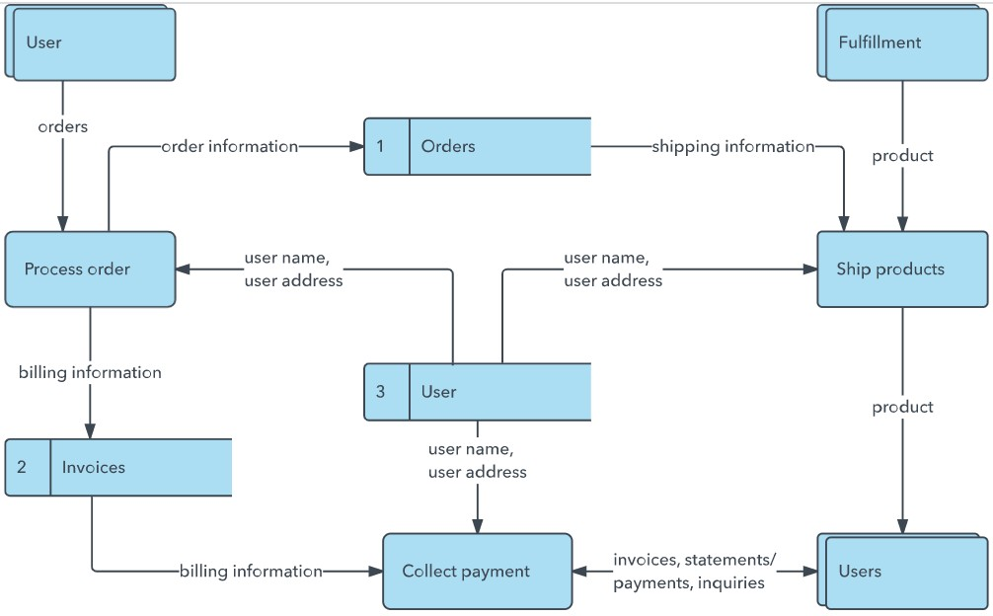
Example: (Simplified)
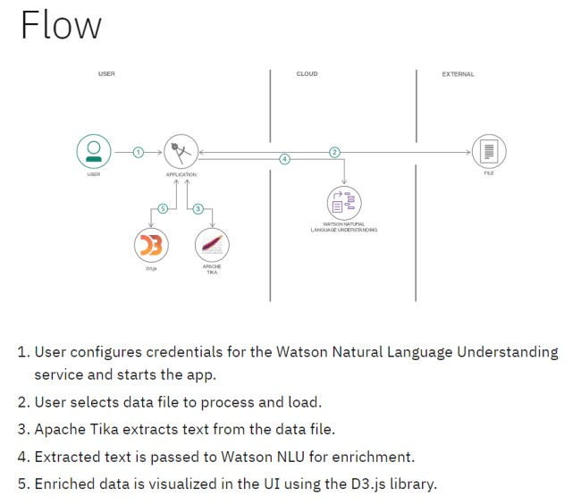

User Stories
Use the below template to list all the user stories for the product.
User Type | Functional  Requirement  (Epic) | User Story Number | User Story / Task | Acceptance criteria | Priority | Release
Customer  (Mobile user) | Registration | USN-1 | As a user, I can register for the application by entering my email, password, and confirming my password. | I can access my account / dashboard | High | Sprint-1
Customer  (Mobile user) | Registration | USN-2 | As a user, I will receive confirmation email once I have registered for the application | I can receive confirmation email & click confirm | High | Sprint-1
Customer  (Mobile user) | Registration | USN-3 | As a user, I can register for the application through Facebook | I can register & access the dashboard with Facebook  Login | Low | Sprint-2
Customer  (Mobile user) | Registration | USN-4 | As a user, I can register for the application through Gmail | I can register using Gmail login. | Medium | Sprint-1
Customer  (Mobile user) | Login | USN-5 | As a user, I can log into the application by entering email & password | I can access the dashboard after login. | High | Sprint-1
Customer  (Mobile user) | Dashboard | USN-6 | As a user, I can view popular and all restaurants on the homepage. | I can see lists of restaurants and their details. | High | Sprint-1
Customer (Web user) | Restaurant Details | USN-7 | As a user, I can view menu items, filter, and add food items to cart. | I can browse food and add to cart from a restaurant page. | High | Sprint-2
Customer Care Executive | Customer Queries | USN-8 | As an executive, I can view and respond to customer complaints or queries. | I can access customer queries and send responses. | Medium | Sprint-3
Administrator | User  Management | USN-9 | As an admin, I can view, approve, or reject restaurant registration requests. | I can update restaurant status as approved or rejected. | High | Sprint-2
Customer  (Mobile user) | Order Placement | USN-10 | As a user, I can place an order and see confirmation. | I can place my order and get a confirmation message. | High | Sprint-2
Administrator | Restaurant Listing | USN-11 | As an admin, I can add/edit/delete restaurant profiles manually. | I can manage restaurant entries from the admin panel. | Medium | Sprint-3
User Type | Functional  Requirement  (Epic) | User Story Number | User Story / Task | Acceptance criteria | Priority | Release
Administrator | Reports  Dashboard | USN-12 | As an admin, I can view overall  user/restaurant/order reports in dashboard | I can track platform activity with summary reports. | Medium | Sprint-3

